Emergency Fax 0355 632 224

I am disabled

I cannot speak

I cannot hear

Who is sending this fax?

Name:________________________________ Your Fax Number:_____________________
Where do you need help?

Street Address:____________________Apt./Room No.____________ Floor:_________

City or location_ ____________________________________________________________

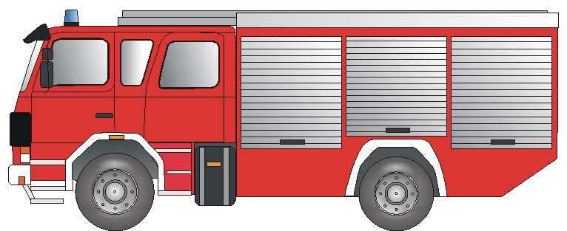
What kind of help?
Was ist geschehen?

______________________________________________________________________________________________________________________________________________________________________________________________________________________________________
Fire Department Fire Rescue Accident



Ambulance Paramedic Injury Illness



POLIZEI

Police Break-In/ Assault Violencei

Please send me addresses and weekend hours for

Doctor Dentist Ear, Nose and Throat Specialist Optometrist
Pharmacy in my local area:
City,County: ____________________________________________________________

Address:______________________________________________________________

Fax:__________________________ Telephone:__________________________

Thank you! Your Signature:_____________________________

Please fax back! Bitte zurückfaxen! Bitte zurückfaxen! Please fax back!

We have received your emergency fax and ______________________________________________

is on the way to your location. Signature of Receiving Dispatcher: _____________________________
Vorlage erstellt von: BF Frankfurt/Main und Deutscher Schwerhörigenbund e. V/Referat Barrierefreies Planen und Bauen./2001/ENGLISCH

